Stock Exchange User Manual

# INTRODUCTION

Stock Exchange module allows us to exchange the products form odoo backend which is already delivered and invoiced.

## FEATURES

* Can easily exchange from return wizard.
* Can specify the exchange quantity..
* Can specify the other products too.
* Separate exchange orders.
* Mapping between exchange orders and original sale orders through smart buttons.
* Mapping between exchange pickings and original picking through smart buttons and widget.
* Preparing the invoice, credit notes automatically.

# INSTALLATION

Now simply follow these steps:

1. Go to settings menu and click on Activate the Developer mode.
2. Now go to apps menu and Click on ‘Update Modules List’.
3. Remove the app’s filter and search for the the word ‘stock_exchange’.
4. Now you will see the module then simply install it.

After installing you will be able to handle different functionality as mentioned in module’s work flows.

# WORK FLOWS

After validating **Stock Picking** of sales order, click **“Return”**

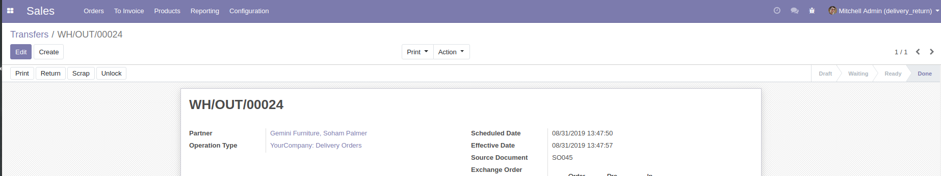

On the wizard we have to click the check box **“To Exchange”** and give the required details and submit the form.

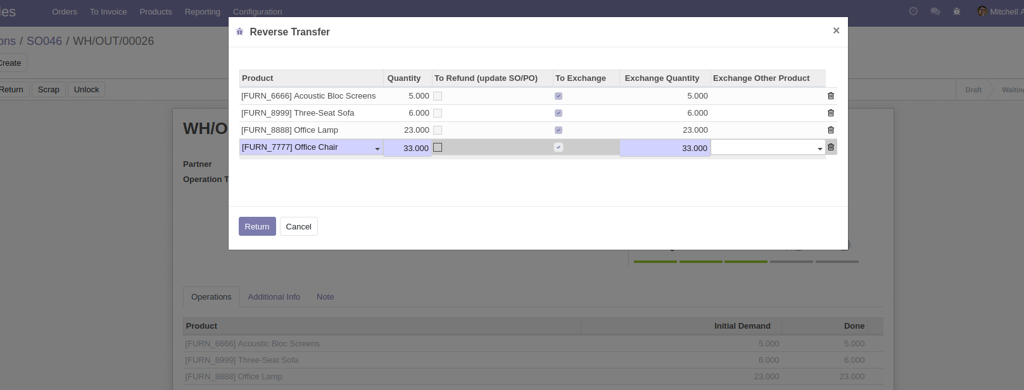

Make sure that it is **invoiced**

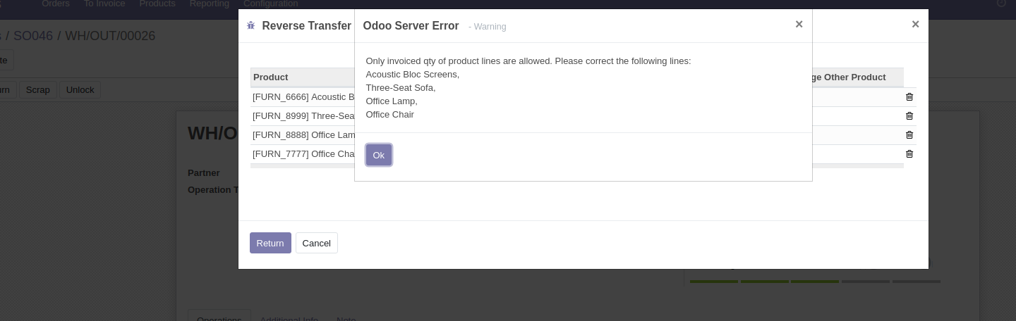

There we can also put **various inputs** like the following pic.

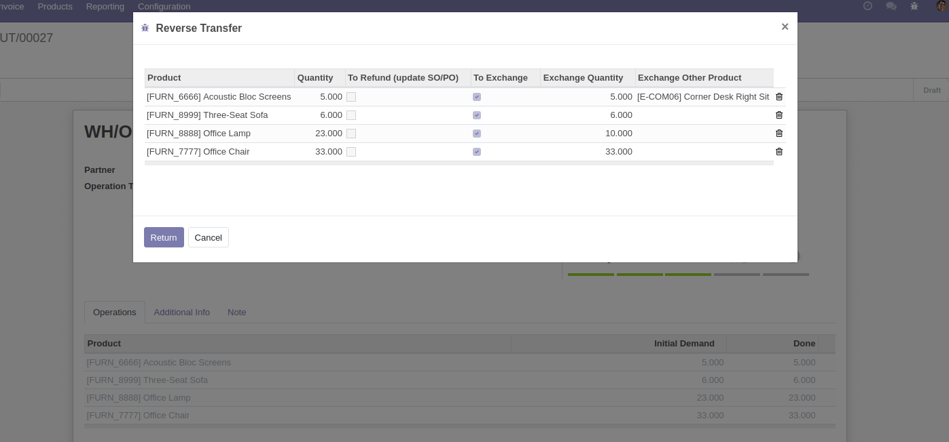

We can see various **smart buttons** on the **sale orders** for linking with **Exchange Orders, Exchange Pickings, Exchange Invoices, Exchange Credit Notes, etc**

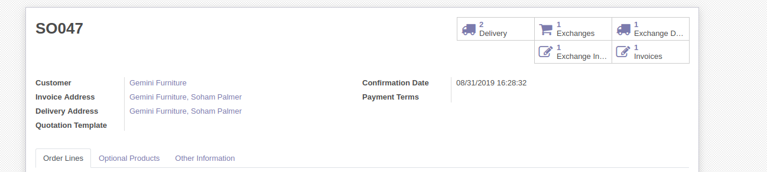

Click the **menu** for the **Exchange Orders**

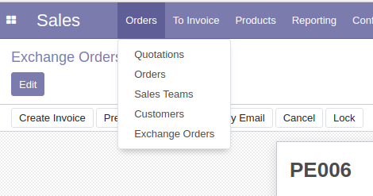

To view select it, from tree view and form view, select a **record**

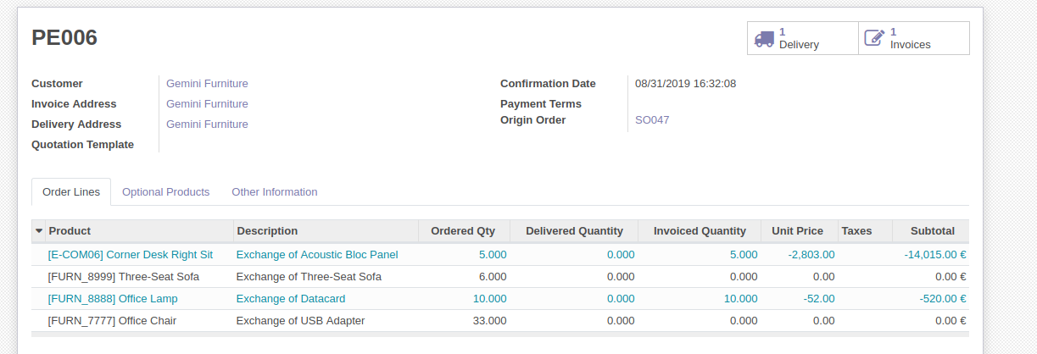

We can see **smart buttons** for therecords of **Credit Notes, Invoices, Exchange Deliveries.**

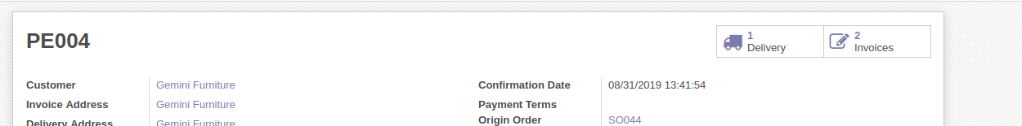

***Exchange Credit Note***

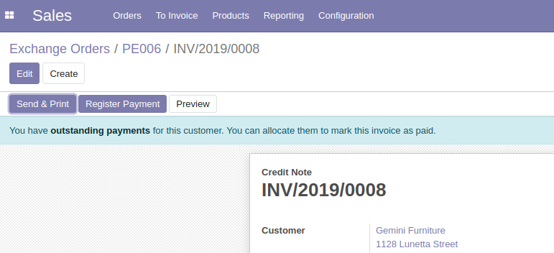

***Exchange Invoice***

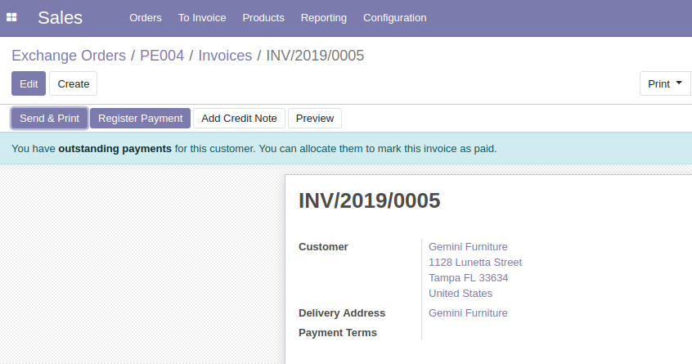

***Exchange Delivery Picking***

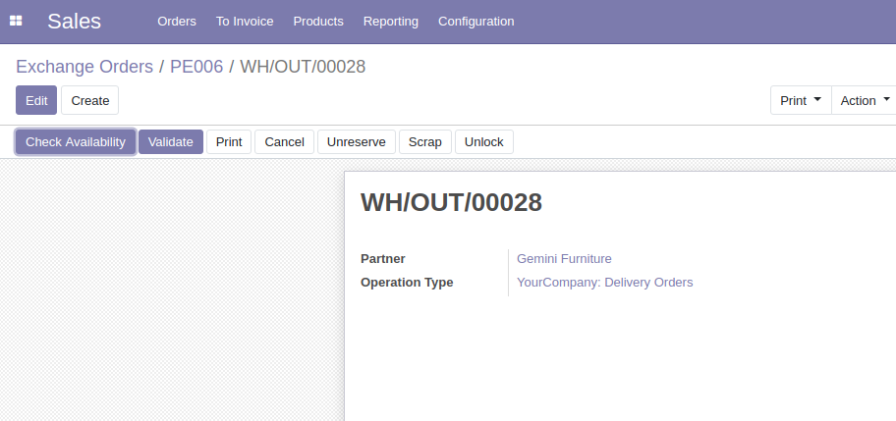

****A widget****

